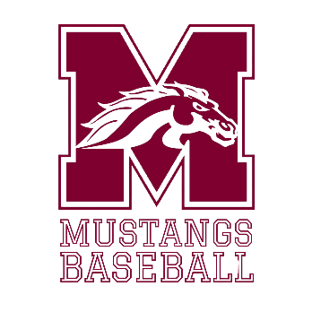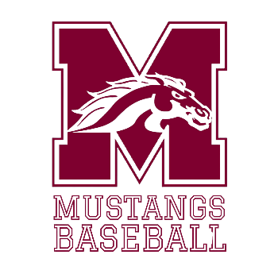

**Winter 2025 Baseball Tryout Schedule & Eligibility Information**

1. **Each player must be fully cleared in the Aktivate system prior to being permitted to participate in any way.**
2. Each student must have a minimum 2.0 grade point average in the previous semester to be eligible. Incoming 6th grade students are all eligible.
3. All students are required to wear baseball pants, t-shirt/jersey & cleats (Molded or Metal) each day for October 8-10th.
4. ON THE 8TH TRYOUTS WILL ONLY BE FOR PLAYERS INTERESTED IN PITCHING AND CATCHING
5. Students should be on site at the (MONTFORD BASEBALL FIELD/LINCOLN BASEBALL FIELD) and prepared to begin 15 minutes prior to their start time in order to be checked in. Students arriving late will not participate that day.
6. All students must attend and participate in tryouts in order to be considered for the team.
7. Water will be provided, but students are strongly encouraged to bring their own water bottle.
8. All equipment for practices should be provided by the player except balls, bases, and other field equipment.

**Tryout Schedule**

**Wednesday, October 8th (Montford):** **Pitchers and Catchers evaluation. (5:30-7:30) (PLAYERS INTERESTED IN PITCHING AND CATCHING ONLY)**

**Thursday, October 9thth (LINCOLN HIGH SCHOOL): Infield/Outfield evaluation (5:30-7:30). (ALL PLAYERS)**

**Friday, October 10th (LINCOLN HIGH SCHOOL): Hitting evaluation. (5:30-8:30) (ALL PLAYERS)**

*Team Roster will be posted to the Montford Baseball website after the coaching staff meets to make cuts.*

*-------------------------------------------------------------------------------------------------------------------------------*

**Monday, October 13th:** Team Practices begin with normal schedule.

1. *Inclement Weather could happen during this time. Tryouts will be “ON” unless the Leon County Schools Weather Alert requires students to stay indoors. In this circumstance, the gym will be utilized.*
2. *Parents are welcome to watch tryouts from the sidewalk but* ***ARE NOT*** *permitted on the field at any time during tryouts. Parents are also asked to not communicate with players or any “coach” from the sidewalk. If tryouts are to be moved to the gym, parents will not be permitted inside due to spacing.*
3. *A mandatory parent meeting for all families that make the final roster will be held in the Montford Weight Room from 6:15-7:00 on Monday, October 13th.*